Date -

Experiment - 4
PHP

PROGRAM 1.1:

AIM :
To write a PHP script that take in an array of strings and returns the list of unique strings in the parameter array

PROGRAM :
<?php
function compute($a1){
$a2 = array_unique($a1);
$a3 = array_values($a2);
return $a3;
}
$a1 = array("a","b","c","a","d","e");
$a2 = compute($a1);
print "The unique elements are\n";
for($x1=0;$x1<count($a2);$x1++){
print $a2[$x1]." ";
}
?>

OUTPUT:

d a b c d e
The unique elements are
a b c d e

RESULT:
Thus the PROGRAM is executed and OUTPUT is obtained

PROGRAM 1.2:

AIM :
To write a PHP script that take in an array of numbers and returns average and median of parameter array

PROGRAM:
<?php
function Average($numbers)
{
# code...
$k = array_sum($numbers);
$n = count($numbers);
$ans = $k/$n;
return $ans;
}

function Median($numbers)
{
if (count($numbers)%2 === 0) {
# code...
$mid=count($numbers)/2;
return (($numbers[$mid-1]+$numbers[$mid])/2);
}
else {
$mid=(count($numbers)-1)/2;
return $numbers[$mid];
}
}

$numbers=array(1,2,3,4,5);
echo ("AVERAGE: " .Average($numbers)."\n");
echo ("MEDIAN: ".Median($numbers)."\n");
?>

OUTPUT:

AVERAGE: 3
MEDIAN: 3

RESULT:
Thus the PROGRAM is executed and OUTPUT is obtained

PROGRAM 1.3:

Aim:
To write a PHP script that take in an array of strings and returns the list of three strings thta occur most frequently in parameter array.

PROGRAM:

<?php
function compute($a1){
$map = array_count_values($a1);
print_r($map);

arsort($map);
$a2 = array_keys($map);
for($x1=0;$x1<count($a2);$x1++)
{
print $a2[$x1];
}

return $a2;
}
$a1 = array("a","b","c","a","b","a","b","a","b","a");
$a2 = compute($a1);
print "The top 3 elements are\n";
for($x1=0;$x1<3;$x1++){
print $a2[$x1];
print " ";
}
?>

OUTPUT:

Array
(
[a] => 5
[b] => 4
[c] => 1
)
The top 3 elements are
a b c

RESULT:
Thus the PROGRAM is executed and OUTPUT is obtained

PROGRAM 1.4:

AIM :
To write a PHP script that take in an array of numbers (pass by value) and two arrays (pass by reference). The first pass by reference must have numbers less than zero and second must have numbers greater than 0

PROGRAM:

<?php
function filter($a, &$p, &$n)
{
$num = count($a);
for ($i=0; $i < $num; $i++) {
if($a[$i] > 0)
{
array_push($p,$a[$i]);
}
elseif($a[$i] < 0)
{
array_push($n,$a[$i]);
}
}
}

$numbers=array(-1,2,-3,4,-5);
$pos = array();
$neg = array();
filter($numbers,$pos,$neg);

echo "Positive array:\n";
for ($i=0; $i < count($pos); $i++) {
echo($pos[$i]." ");
}
echo "\n";
echo "Negative array:\n";
for ($i=0; $i < count($neg); $i++) {
echo($neg[$i]." ");
}

echo "\n";
?>

OUTPUT:
Positive array:
2 4
Negative array:
-1 -3 -5

RESULT:
Thus the PROGRAM is executed and OUTPUT is obtained
PROGRAM 1.5:

AIM :
To write a PHP script that take in an string of numbers separated by spaces and returns first four digit number in the string, else return none.

PROGRAM:

<?php
function compute($a1){
$a3 = explode(' ',$a1);
$a2 = array_values($a3);
for($x1=0;$x1<count($a2);$x1++){
if(strlen($a2[$x1]) == 4){
$ans = $a2[$x1];
return $ans."\n";
}
}
return "false";
}
$a1 ="1 2 34 12 4455";
print $a1."\n" ;
$a2 = compute($a1);
print $a2 . "\n";
$a1 ="1 2 34 12 345";
print $a1."\n" ;
$a2 = compute($a1);
print $a2 . "\n";
?>

OUTPUT:

1 2 34 12 4455
4455
1 2 34 12 345
false

RESULT:
Thus the PROGRAM is executed and OUTPUT is obtained

PROGRAM 1.6:

AIM :
To write a PHP script that take in a file variable of a file of text where the words are separated by spaces or colons and returns the word that appears most often in the file

PROGRAM:

<?php
function findMax($file,$fname)
{
# code...
$filecontents = file_get_contents($fname);
echo $filecontents;
$words = preg_split('/[\s|:]+/', $filecontents, -1, PREG_SPLIT_NO_EMPTY);
$arr = array_count_values($words);
print_r($words);
$max = 0;
$word = "";
foreach ($arr as $key => $value) {
# code...
if($value > $max)
{
$max = $value;
$word = $key;
}
}
return $word;
}

$fname = "prog1_6.txt";
$file = fopen($fname,"r") or die("Unable to open file");
echo findMax($file,$fname);
?>

OUTPUT:

Input File :
harry potter lilly:potter:james:potter

OUTPUT :
potter

RESULT:
Thus the PROGRAM is executed and OUTPUT is obtained

PROGRAM 1.7:

AIM :
To write a PHP script that take in an string containing words that are delimited on the left by spaces and on the left with spaces, commas, periods or question marks and returns three most common words in the string that has 3 or more letters

PROGRAM:
<?php
function compute($a1){
$a3 = preg_split('/[\s]+|\.|\,/',$a1);
$a2 = array_values($a3);
$ff = array();
for($x=0;$x<count($a2);$x++){
if(strlen($a2[$x])>3){
array_push($ff,$a2[$x]);
}
}
$map = array_count_values($ff);
arsort($map);
$ans = array_keys($map);
return $ans;
}
$a1 =" hello, there welcome. a vdgdhfghj, welcome.";
$a2 = compute($a1);
print "The top 3 elements are\n";
for($x1=0;$x1<3;$x1++){
print $a2[$x1];
print " ";
}
?>

OUTPUT:
The top 3 elements are welcome hello there

RESULT:
Thus the PROGRAM is executed and OUTPUT is obtained

PROGRAM 2:

AIM :
To write an XHTML document that includes an anchor tag that calls a PHP document. Also write the PHP document, which returns a which returns a randomly chosen greeting of five different greetings. The greetings must be stored as constant strings in the script. A random number between 0 and 4 can be compted by a random function.

PROGRAM:
<?php
function greetingCall(){
define("GREETING1","Have a nice day.");
define("GREETING2","Thank you.");
define("GREETING3","Welcome.");
define("GREETING4","Nice meeting you.");
define("GREETING5","Hope to see you again.");
$greet = array(GREETING1,GREETING2,GREETING3,GREETING4,GREETING5);
$index = rand(0,4);
echo "<div>".$greet[$index]."</div>";
}
greetingCall();
?>

XHTML:
<!DOCTYPE html PUBLIC "-//W3C//DTD XHTML 1.0 Transitional//EN" "http://www.w3.org/TR/xhtml1/DTD/xhtml1-transitional.dtd">
<html xmlns="http://www.w3.org/1999/xhtml">
<head>
<title>
PROGRAM 2
</title>
</head>
<body>
<a href="http://localhost:8000">Click to view Greeting</a>
</body>
</html>

OUTPUT:

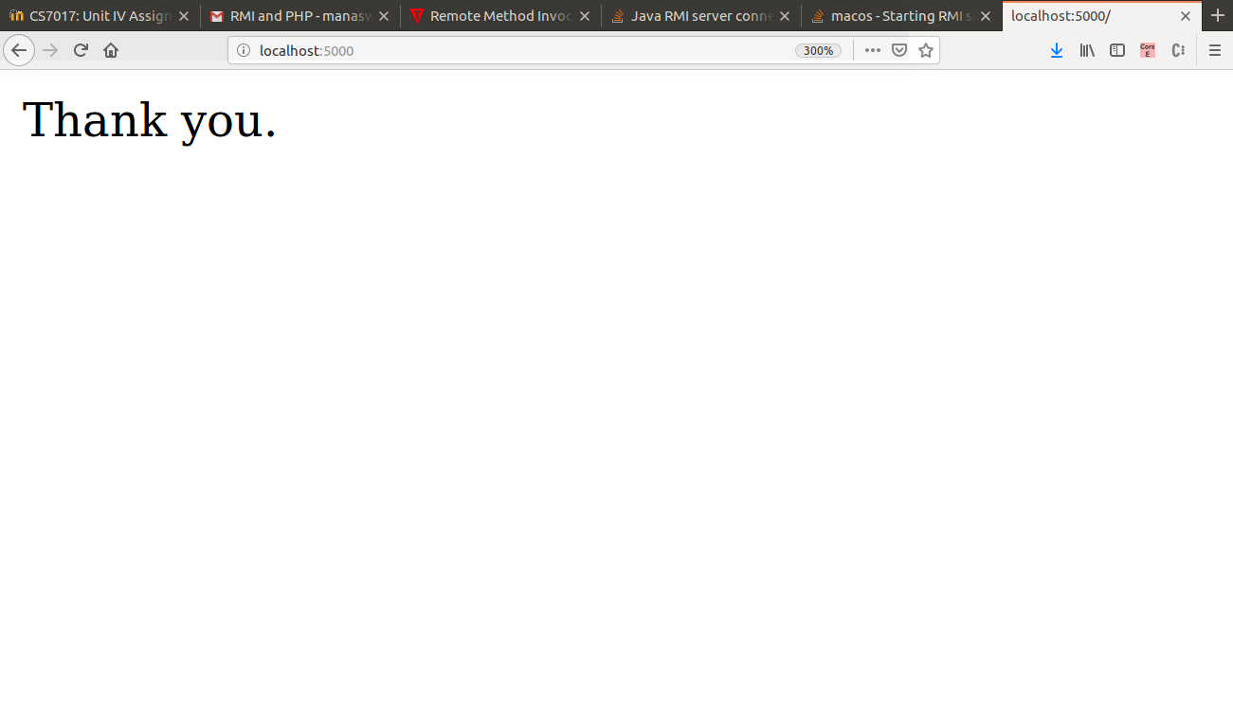
RESULT:
Thus the PROGRAM is executed and OUTPUT is obtained

PROGRAM 3:

AIM :
To write an XHTML document to create a form that collects favorite popular songs, including the name of the song, the composer, and the performing artist or group. The document must call one PHP script where the form is submitted and another to request a current list of survey RESULTs.

PROGRAM:
<!DOCTYPE html PUBLIC "-//W3C//DTD XHTML 1.0 Transitional//EN" "http://www.w3.org/TR/xhtml1/DTD/xhtml1-transitional.dtd">
<html xmlns="http://www.w3.org/1999/xhtml">
<head>
<title>
PROGRAM 3
</title>
</head>
<body>
<?php
$display = "";
$content = $artist = $name = $song = $composer = "";
if ($_SERVER["REQUEST_METHOD"] == "POST")
{
$file = fopen("prog3.txt","r");
$content = "Name: " . $_POST["name"] . "\n" . "Favorite Song: " . $_POST["song"] . "\n" . "Composer: " . $_POST["composer"] . "\n" . "Artist/Group: " . $_POST["artist"] . "\n\n";
$myfile = file_put_contents('prog3.txt', $content.PHP_EOL , FILE_APPEND | LOCK_EX);
$display = file('prog3.txt');
}
?>

<form method="post" action="<?php htmlspecialchars($_SERVER["PHP_SELF"]);?>">
Name: <input type="text" name="name" id="name" value="<?php echo $name;?>"/><br />
Favorite Song: <input type="text" name="song" id="song" value="<?php echo $song;?>"/><br />
Composer: <input type="text" name="composer" id="composer" value="<?php echo $composer;?>"/><br />
Performing Group (or) artist <input type="text" name="artist" id="artist" value="<?php echo $artist;? >"/><br/>
<input type="submit" value="submit" /><br />
<br />
<br />
<div>
<?php
for ($i=0; $i < count($display); $i++) {
echo $display[$i] . "<br>";
}
?>
</div>
</form>
</body>
</html>

OUTPUT :

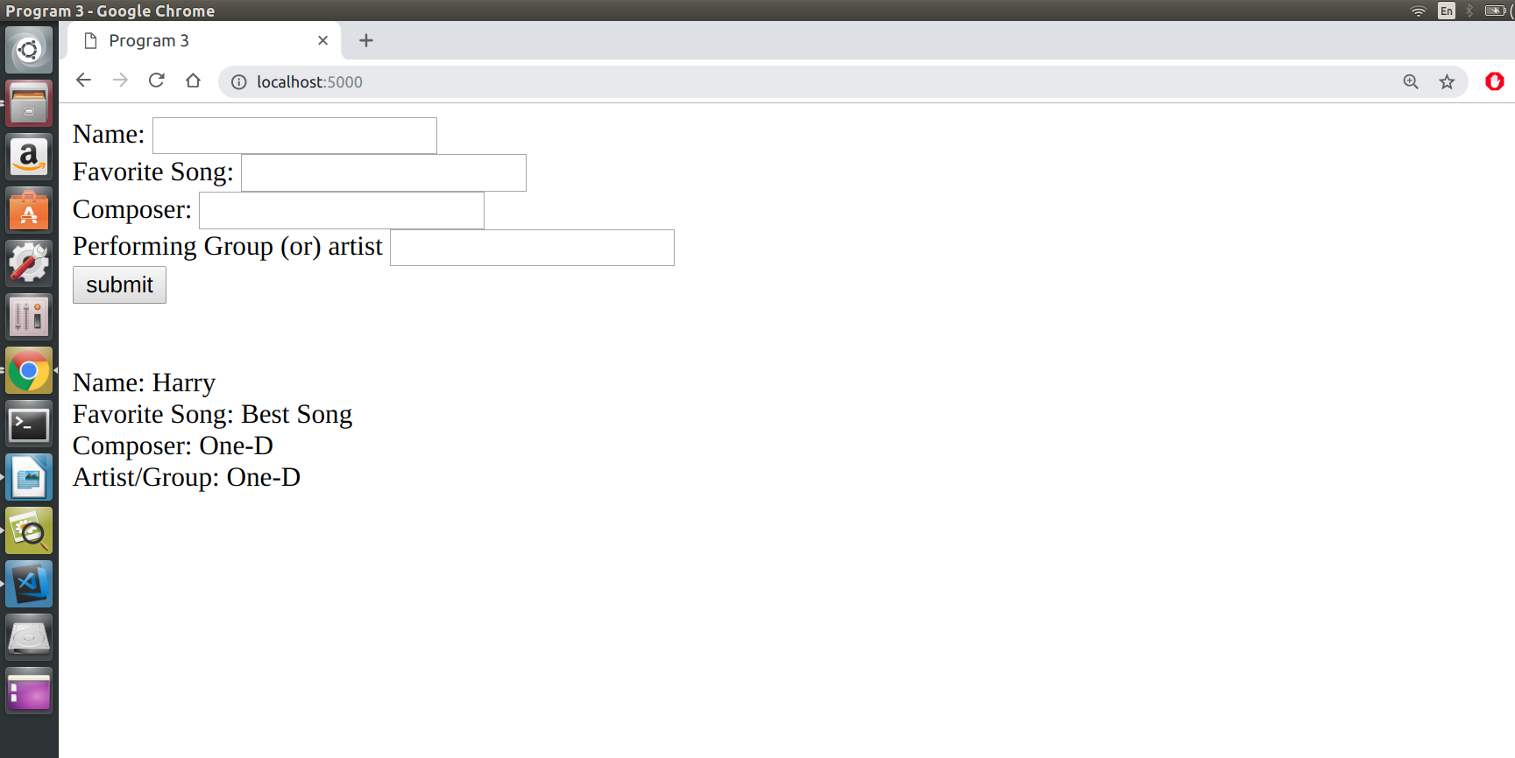

RESULT:
Thus the PROGRAM is executed and OUTPUT is obtained

PROGRAM 4:

AIM:
To write an XHTML document to provide a form that collects names and telephone numbers. The mobile numbers must be in the format +dd-dddd-dddddd. Write a PHP script that checks the submitted mobile number to be sure that it comfirms to the required format
and returns a response indicating whether the number was correct.

PROGRAM :

<!DOCTYPE html PUBLIC "-//W3C//DTD XHTML 1.0 Transitional//EN" "http://www.w3.org/TR/xhtml1/DTD/xhtml1-transitional.dtd">
<html xmlns="http://www.w3.org/1999/xhtml">
<head>
<title>
PROGRAM 4
</title>
</head>
<body>
<?php
$mobileErr = "";
$mobile = "";
$name = "";
if ($_SERVER["REQUEST_METHOD"] == "POST")
{
if(empty($_POST["mobile"])) {
$mobileErr = "Mobile number is required";
} else {
$mobile = test_input($_POST["mobile"]);
if(!preg_match("/\+\d{2}-\d{4}-\d{6}/", $mobile))
{
$mobileErr = "invalid Format";
}
}
}
function test_input($data) {
$data = trim($data);
$data = stripslashes($data);
$data = htmlspecialchars($data);
return $data;
}
?>

<h2>Form Validation</h2>
<form method="post" action="<?php htmlspecialchars($_SERVER["PHP_SELF"]);?>">
Name: <input type="text" name="name" value="<?php echo $name;?>" /><br><br>
Mobile: <input type="text" name="mobile" value="<?php echo $mobile;?>" />
<span class="error">* <?php echo $mobileErr;?></span>
<br /><br />
<input type="submit" name="submit" value="Submit" />
</form>
</body>
</html>

OUTPUT:

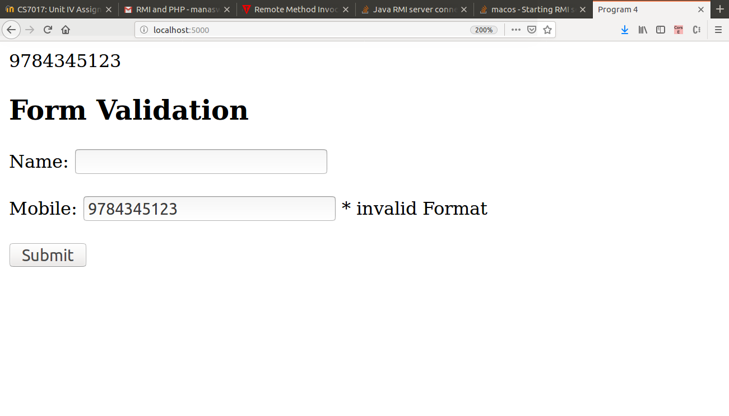

RESULT:
Thus the PROGRAM is executed and OUTPUT is obtained

PROGRAM 5:

AIM :
To modify the PHP script from Exercise 2 to count the number of visitors and display the numbers for each visitor.

PROGRAM:
<?php
function greetingCall(){
define("GREETING1","Have a nice day.");
define("GREETING2","Thank you.");
define("GREETING3","Welcome.");
define("GREETING4","Nice meeting you.");
$greet = array(GREETING1,GREETING2,GREETING3,GREETING4,GREETING5);
$index = rand(0,4);
$fp = file_get_contents("prog5.txt");
$val = (int)$fp;
$val+=1;
$fp = (string)$val;
print "<div>".$greet[$index]."</div>";
print "<div> Client Number ".$val."</div>";
}
greetingCall();
?>

XHTML:
<!DOCTYPE html PUBLIC "-//W3C//DTD XHTML 1.0 Transitional//EN" "http://www.w3.org/TR/xhtml1/DTD/xhtml1-transitional.dtd">
<html xmlns="http://www.w3.org/1999/xhtml">
<head>
<title>
PROGRAM 5
</title>
</head>
<body>
<a href="http://localhost:8000">Click to view Greeting</a>
</body>
</html>

OUTPUT:

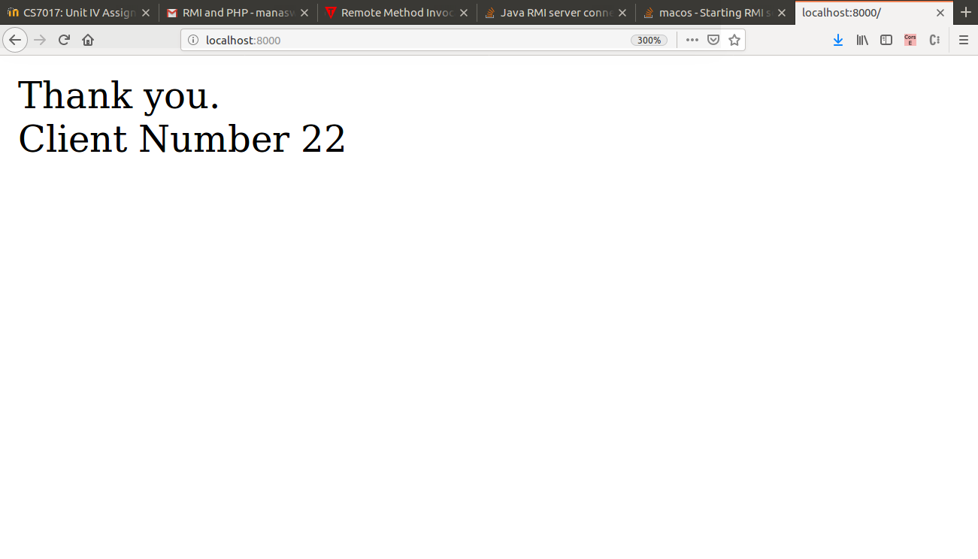
RESULT:
Thus the PROGRAM is executed and OUTPUT is obtained
PROGRAM 6:

AIM :
To implement the following modules using Server Side Scripting (PHP)
(i) Gathering form data.
(ii) Querying the database.
(iii) Response generation.
(iv) Session management.
(v) Use MySQL or JDBS or Oracle.

PROGRAM :

<html>
<head>
<style>
body{
display: inline-block;
width:100%;
height:100%;
text-align:center;
}
</style>
</head>
<body>
<?php
session_start();
?>
<?php
$regno = "";
$pwd = "";
$regErr = "";
$pwdErr = "";
$name = "";
$address = "";
$mobile = "";
$time = $_SERVER['REQUEST_TIME'];
$timeout_duration = 60;
if (isset($_SESSION['LAST_ACTIVITY']) && ($time - $_SESSION['LAST_ACTIVITY']) > $timeout_duration) {
session_unset();
session_destroy();
session_start();
}
if ($_SERVER["REQUEST_METHOD"] == "POST")
{
if(empty($_POST["regno"])) {
$regErr = "Student Registeration number is required";
}
if(empty($_POST["pwd"])) {
$pwdErr = "Password is required";
}

if(isset($_POST["reg"]) && isset($_POST["pwd"])){

$servername = "localhost";
$username = "root";
$password = "0611";
$dbname = "test";

$conn = new mysqli($servername,$username, $password,$dbname);
if($conn -> connect_error){
die("Connection failed: ".$conn- >connect_error);
}

$regno = $_POST['regno'];
$pwd = $_POST['pwd'];

$sql = "SELECT name,address,mobile,id from Tab1 where id = '$regno' and password = '$pwd';";
$result = $conn->query($sql);
if($result->num_rows > 0){
while($row = $result->fetch_assoc()){
$name = $row["name"];
$address = $row["address"];
$mobile = $row["mobile"];
$regno = $row["id"];
}
}
else{
print "Data mismatch. Please try again.";
$regno = "";
$pwd = "";
}

$conn ->close();
}
$_SESSION['LAST_ACTIVITY'] = $time;
}
?>
<div><h1>Depatment of Computer Technology</h1></div>
<br>
<br>
<form class = "form1" method="post" action="<?php htmlspecialchars($_SERVER["PHP_SELF"]);?>">
<h3>
Registeration No: <input type="text" name="regno" id ="regno" value="<?php echo $regno;?>" />
<span class="error">* <?php echo $regErr;?></span>
<br /><br />
Password: <input type="password" name="pwd" id ="pwd" value="<?php echo $pwd;?>" />
<span class="error">* <?php echo $pwdErr;?></span>
<br /><br />
<input type="submit" name="submit" value="submit" />
<br>
<br>
<div>
Student Name: <input type="text" name="name" id = "name" value="<?php echo $name;?>" />
Registeration No: <input type="text" name="reg" id = "reg" value="<?php echo $regno;?>" />
Address: <input type="text" name="address" id = "address" value="<?php echo $address;?>" />
Student Name: <input type="text" name="mobile" id = "mobile" value="<?php echo $mobile;?>" />
</div>
</h3>
</form>
</body>
</html>

OUTPUT :

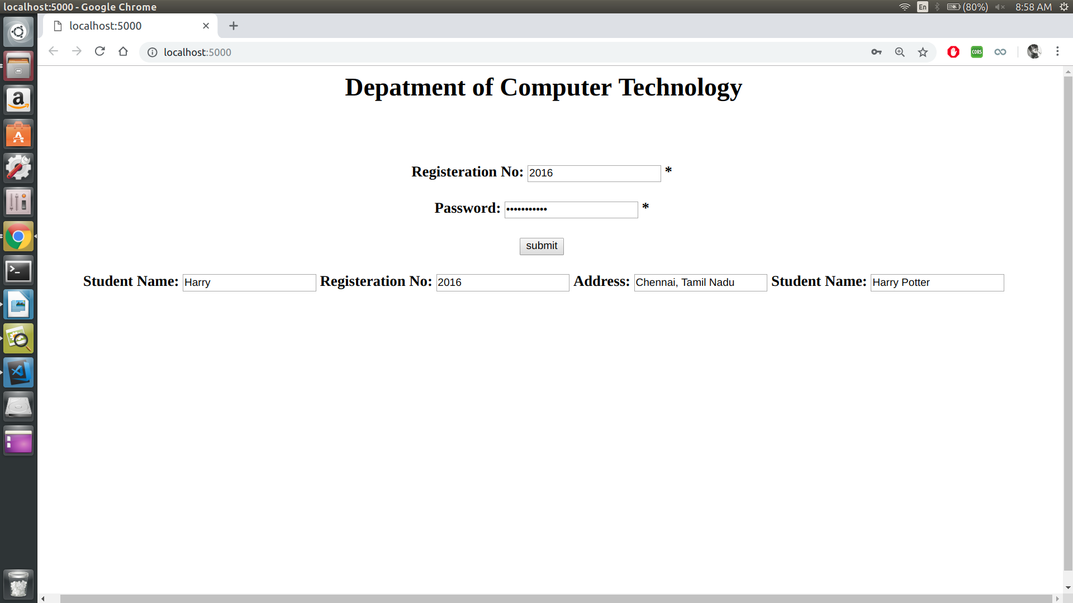

RESULT:
Thus the PROGRAM is executed and OUTPUT is obtained.

